Rosca Dorin

Matematica Discreta

Lucru Individual

Ex.1

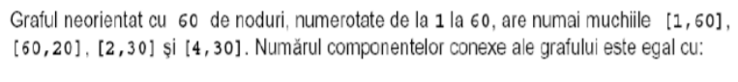

Raspuns:b)56

Din 60 de noduri scadem 6 si adaugam 2

Ex.2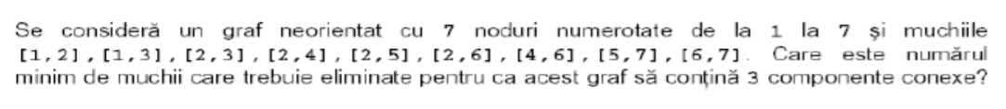

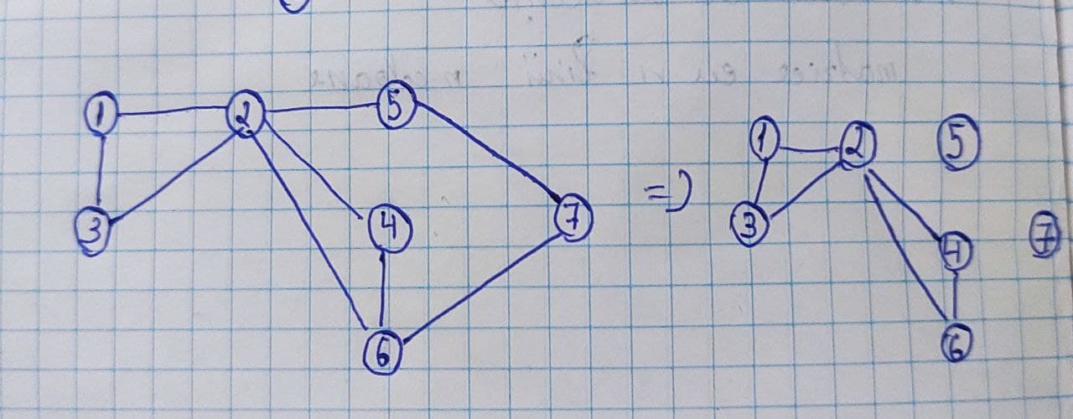

Raspuns:3

Ex.3

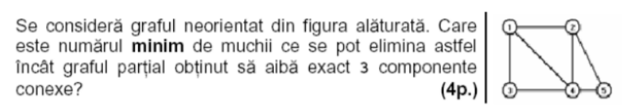

Raspuns:b)4

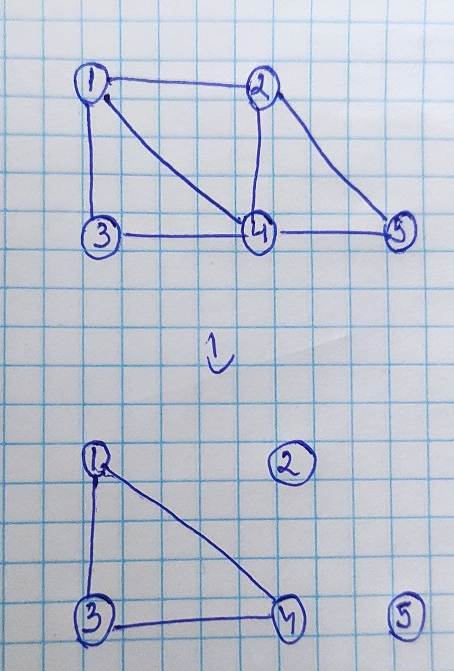

Ex.4

Raspuns:d)15

Intr-un graf cu n noduri avem n\*(n-1)/2 muchii

I+5 noduri ramase

7\*6/2=21

6\*(6-1)/2=15